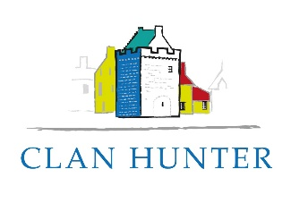 | Request a Refund / Return an Item

Note our terms and conditions, which describe your rights to return items and obtain refunds.
Please complete this form and send it to contact@clanhunterscotland.com.
For event cancellations only, you may alternatively contact the Administrator by telephone on 07980 209060.

I wish to (tick as appropriate):
cancel an event
cancel a membership application
cancel a voucher I have purchased
return an item I have bought

Details of cancellation or item:
e.g. date of event, number of places to be cancelled, description of item

Date of purchase:
Cost of purchase:

For purchased items, you must return them to the Administrator in their original packaging and original condition (unless they are faulty). You may do this at a Clan event or by returning them to Hunterston KA23 9QG. Return postage will not be refunded. Refunds will only be made once items have been received by us.

